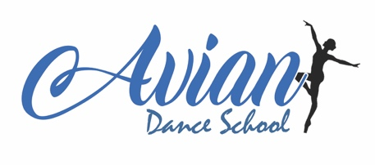

**AVIAN DANCE SCHOOL HEALTH AND SAFETY POLICY**

Avian Dance School takes their responsibility to ensure the safety of its staff and students seriously.

* All parents must complete a registration form when joining the school with clear information regarding emergency contacts and any relevant medical history.
* It is a parents/guardians responsibility to notify the school of any changes to their emergency contact details.
* In case of a fire emergency, all teachers have a clear understanding of procedures to follow.
* The school undertakes a risk assessment of all halls or studios that classes are held in.
* We ensure every teacher has access to a first aid box and we keep a central log of any accidents that occur in classes.
* All teachers are required to have up to date first aid training.
* All Avian staff are required to have an enhanced DBS with barred from working with children and annual safeguarding training.
* Parents should understand that dance is an active sport and injuries can happen, the school accepts no responsibility for injuries sustained via any means other than a teacher’s negligence.
* Students will be supervised during class time only and parents/guardians must ensure the safety of their children in the car park, waiting and changing areas.
* Students/parents or guardians should inform the teacher of any special health considerations or existing injuries before participating in class.
* Dress code must be observed at all times to minimise opportunity for injuries.
* Water is permitted in cap bottles.
* No child will be allowed to leave class with anyone other than the parent/guardian unless confirmed on the registration form or with the teacher prior to the class.
* Equipment will be cleaned regularly with correctly diluted cleaning products and left over night before use.
* Costumes and material equipment to be washed after use using non bio detergent.
* Equipment to be stored safely in the allocated room and only staff and teachers are permitted to enter
* Equipment stored at the side of the room to be safely stacked and is not to be climbed on.
* Tape on the floor will be re administered as necessary to reduce risk of tripping.
* Students are asked not to bare full weight on ballet barres attached to walls to avoid damage and injury.
* Parents waiting in reception with siblings or other children are asked to supervise them at all times and ensure they are being safe. These children are the responsibility of the guardian they came with or are waiting with.
* No-one to be granted access to the building without Principal’s/teacher’s/staff’s/hirer’s permission.
* Use of the kettle in the kitchen is for staff and hirers who have requested it only.
* Any problems with the studio such as broken doors/toilets etc to be reported to one of the school Principals or staff member immediately.

Principals: Harriet Wigger, Aimee Cooper and Lauren Stearman

Last reviewed: 06/08/2024